6 aprile

ESERCIZI ( come sempre puoi lavorare in questo file e poi inviare a soniabaratella1971@libero.it )
N.1
Leggi e ascolta :

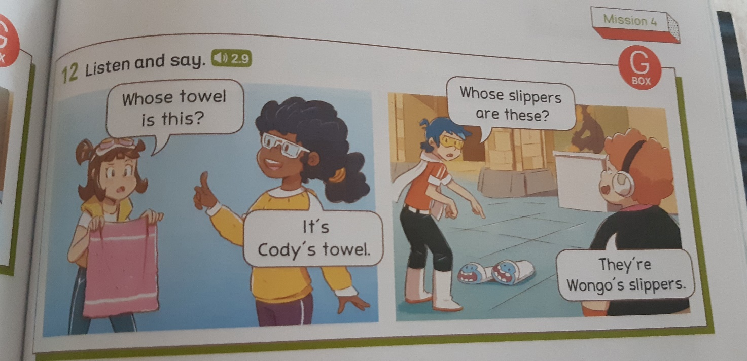

N.2
COMPLETA IL DIALOGO ..POI ASCOLTA E CONTROLLA
Complete the dialogue . Listen and check
Segui l’esempio

1 WHOSE torch IS THIS? IT’S Max’S TORCH
2 towel ? Cody
3 slippers ? Lizzy
4 camera ? Max
5 pyjamas ? Ashley
6 toohbrush ? Lizzy
7 shower cap ? Ashley
8 bathrobe ? Cody

Guarda il video per ricordare la regola
https://youtu.be/7dPs4qnbUBY

N.3
SCEGLI LE FRASI GIUSTE
Choose the correct sentences (put a tick)
◊ THIS IS MY SISTER TABLET
◊ THIS IS MY SISTER’S TABLET

◊THE GARDEN OF THIS HOUSE IS SMALL
◊ THIS HOUSE’S GARDEN IS SMALL

◊THESE ARE MY FRIENDS’ SLIPPERS
◊THESE ARE MY FRIENDS’S SLIPPERS

◊THIS IS TIM AND JOHN BEDROOM
◊THIS IS TIM AND JOHN’S BEDROOM

◊THE COMPUTER’S MONITOR IS BLACK
◊THE MONITOR OF THE COMPUTER IS BLACK

◊THIS IS MAX’S MAGNIFYING GLASS ( lente da ingrandimento )
◊THIS IS MAGNIFYING GLASS’S MAX

◊THIS IS WONGOS TOOTHBRUSH
◊THIS IS WONGO’S TOOTHBRUSH

N.4
LEGGI LE RISPOSTE E SCRIVI LE DOMANDE (usa whose ..con la regola, nella lezione della settimana scorsa 1 aprile)
Read the answers and write questions

1) ?
It’s my teacher’s tablet
2) ?
It’s my dog’s ball

3) ?
They’re the crew’s rucksacks

4) ?
It’s my torch

N.5
SCRIVI LE PAROLE IN ORDINE
Put the words in order
- ARE- WHOSE -THESE- PYJAMAS?

- PYJAMAS – THEY- CODY’S -ARE

- NOT – RUCKSACKS- IS -ASHLEY’S – THIS

